|  |
| --- |
|  |

|  |
| --- |
| **NEGATIVE FEEDBACK AMPLIFIERS** |
|  |
|  |
|  |
|  |
|  |
|  |
|  |

**Negative Feedback Amplifiers**

**Basic Concept of Negative Feedback Amplifier**

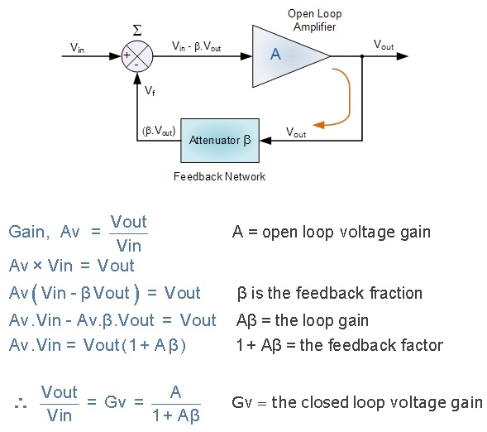

**Negative Feedback Amplifier Topologies**

**Series-Shunt Negative Feedback Amplifier**

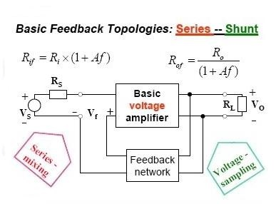

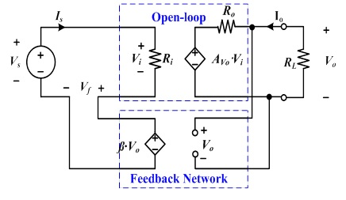

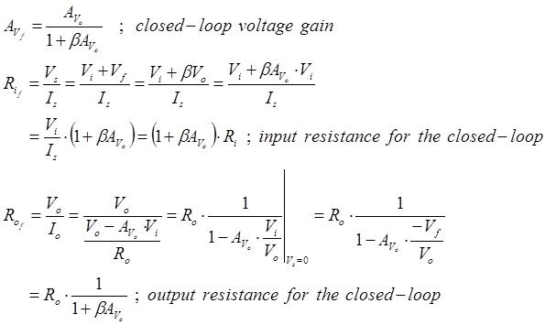

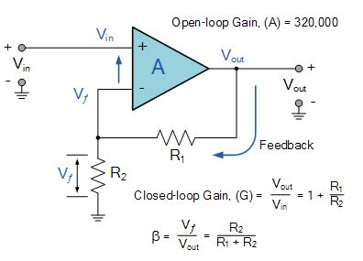

**Shunt-Shunt Negative Feedback Amplifier**

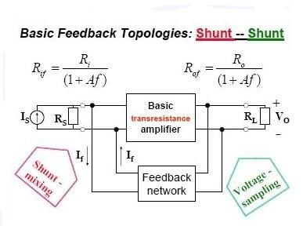

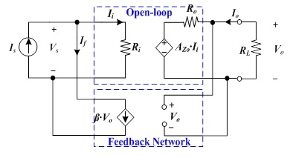

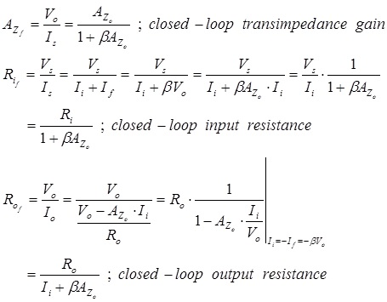

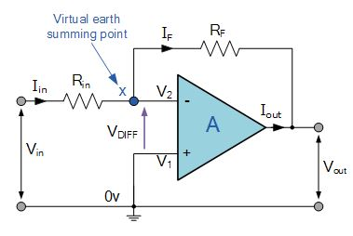

**Frequency Response of Negative Feedback Amplifier**

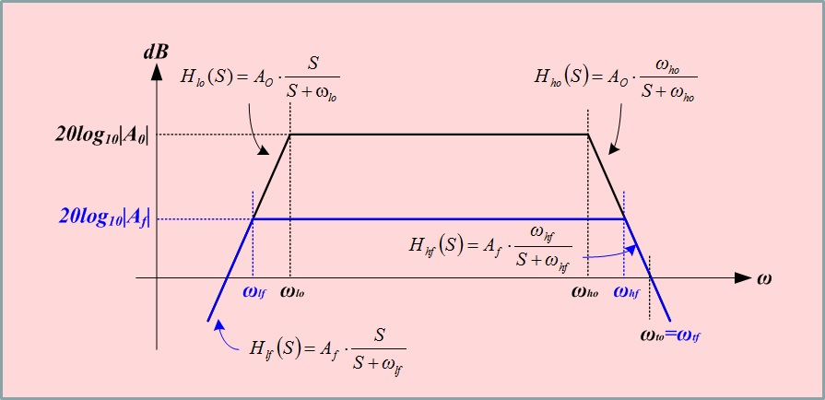

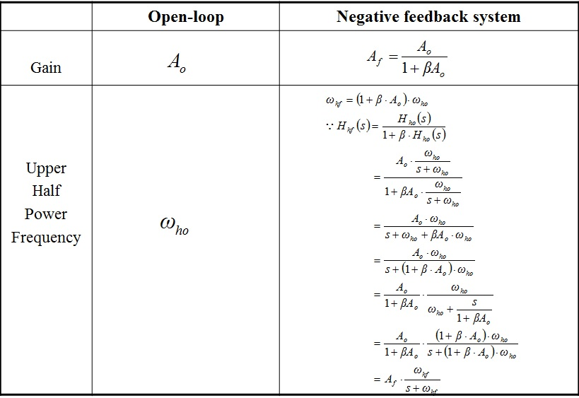

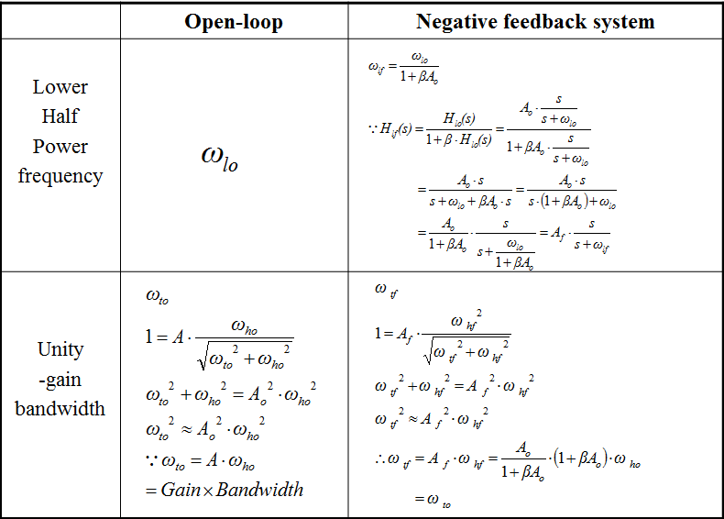

**Transient Response of Negative Feedback Amplifier**

**Impulse Responses with respect to Pole locations**

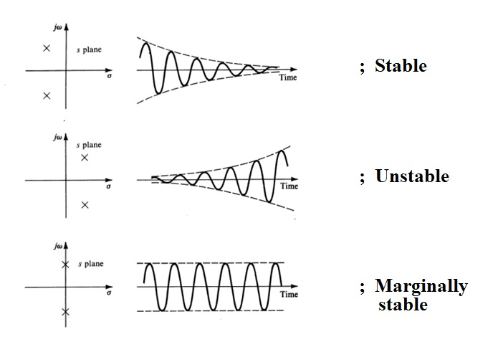

**Movement of Poles in Negative Feedback Amplifier**

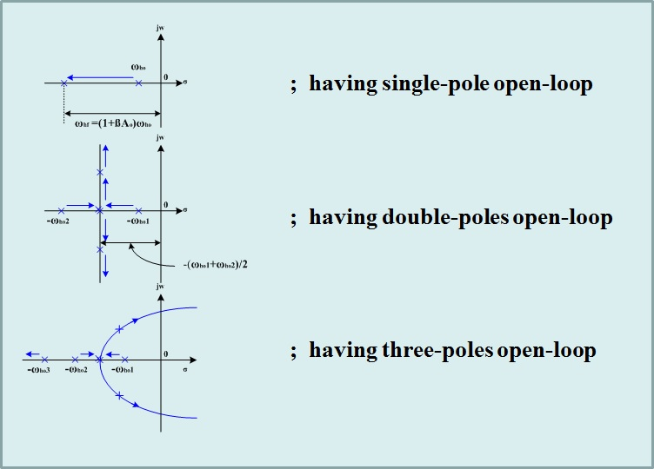

**Example 1. Comparision Between Open Loop and Closed Loop Amplifiers**

1. Voltage gain
2. Input Resistance
3. Output Resistance
4. Frequency Response
5. Transient Response

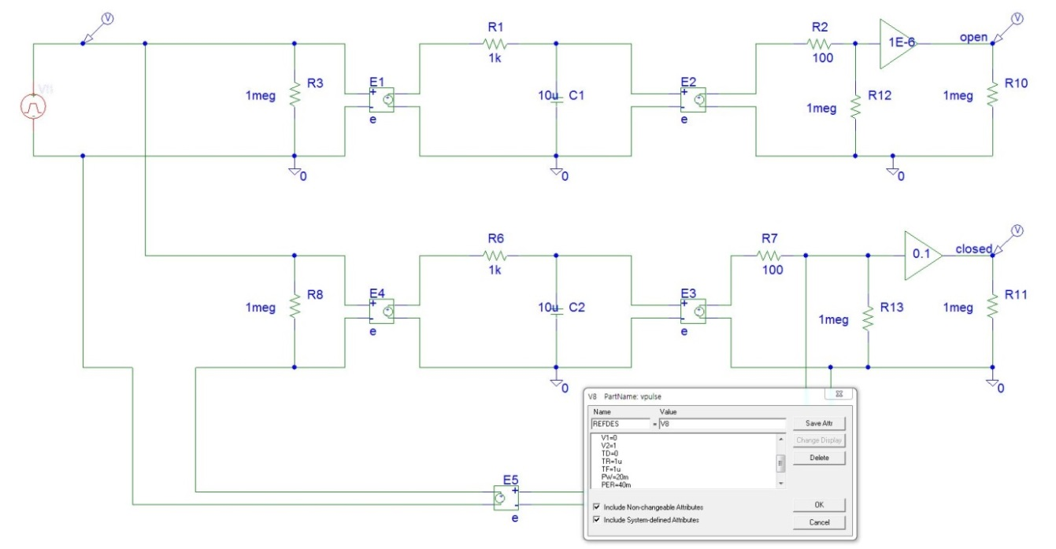

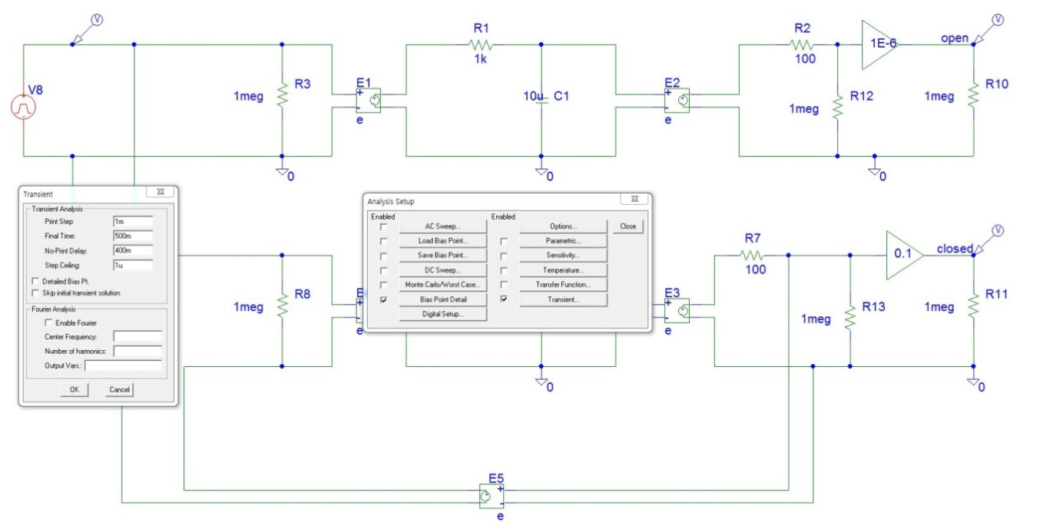

**Example 2. Frequency & Transient Responses due to pole types**

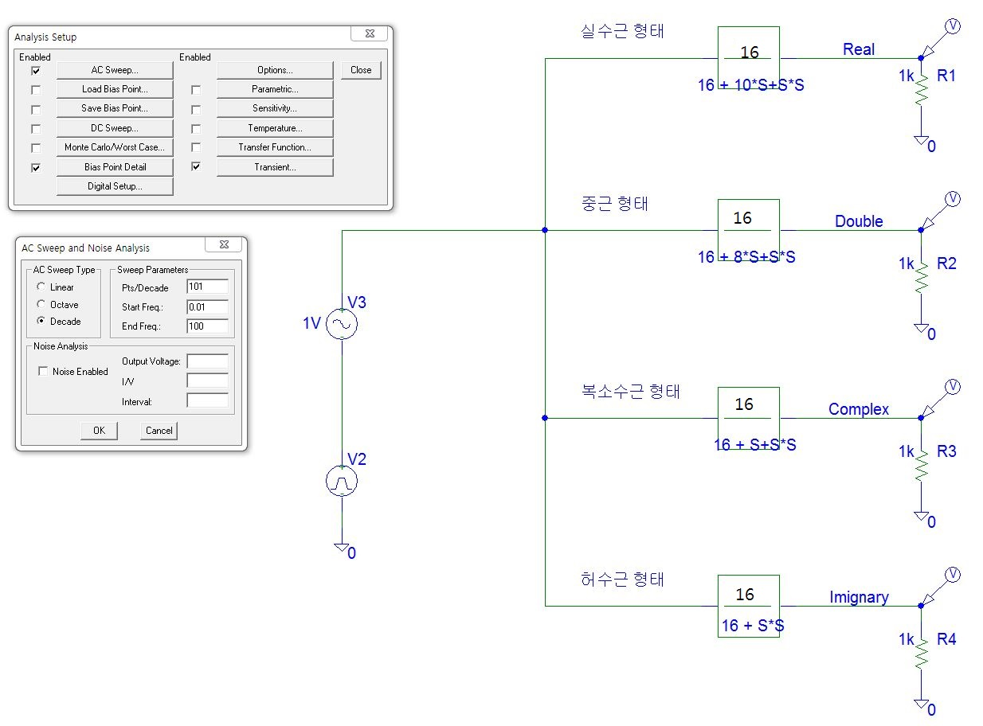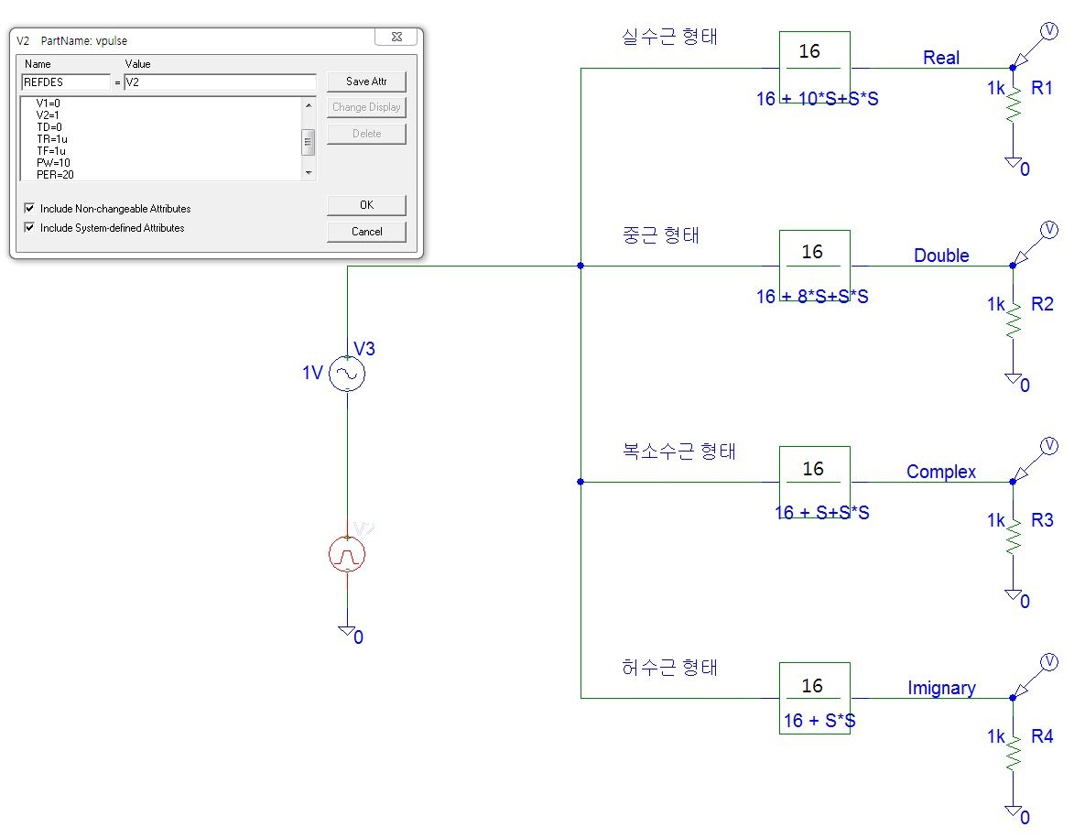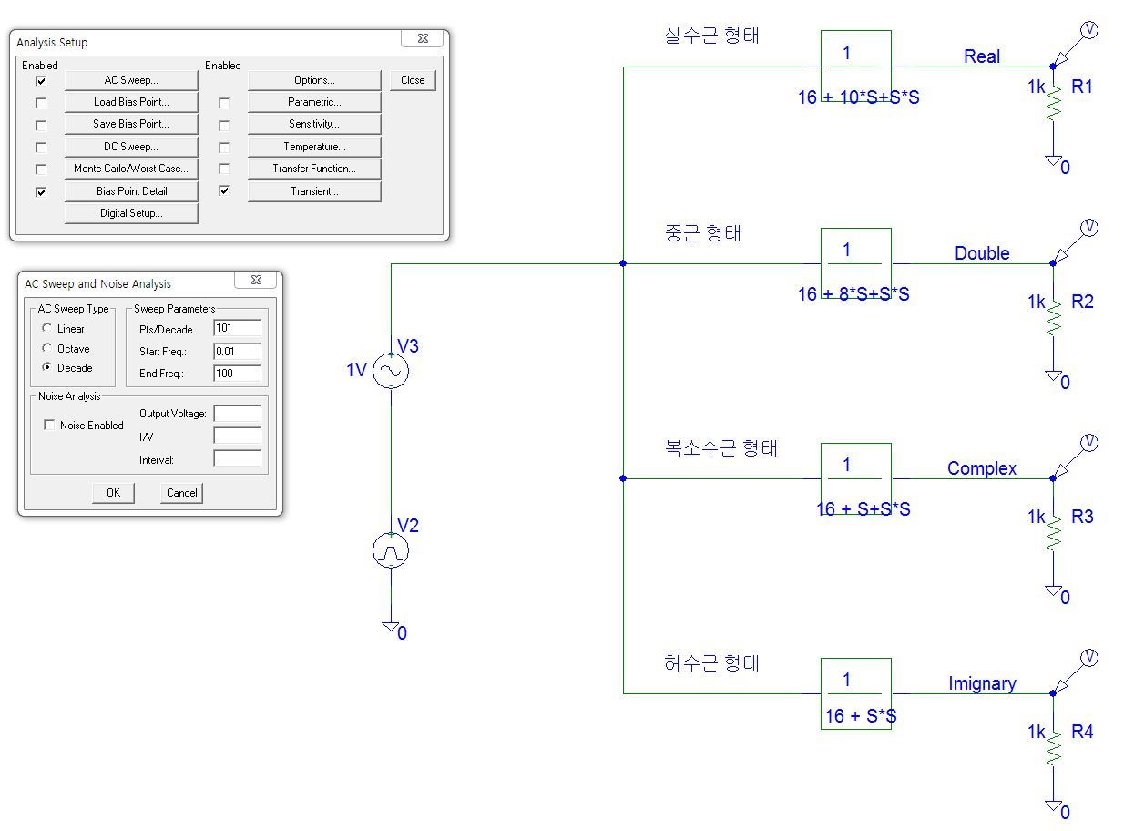

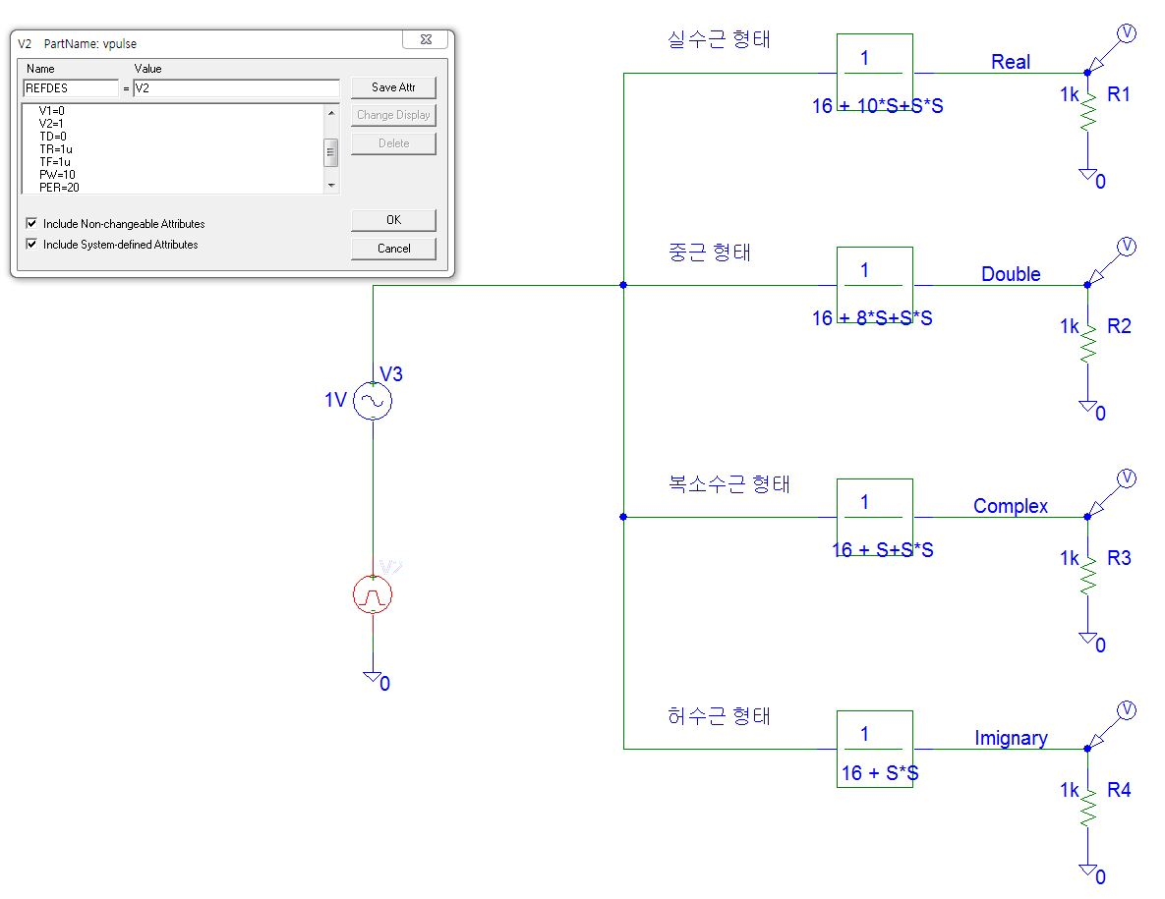

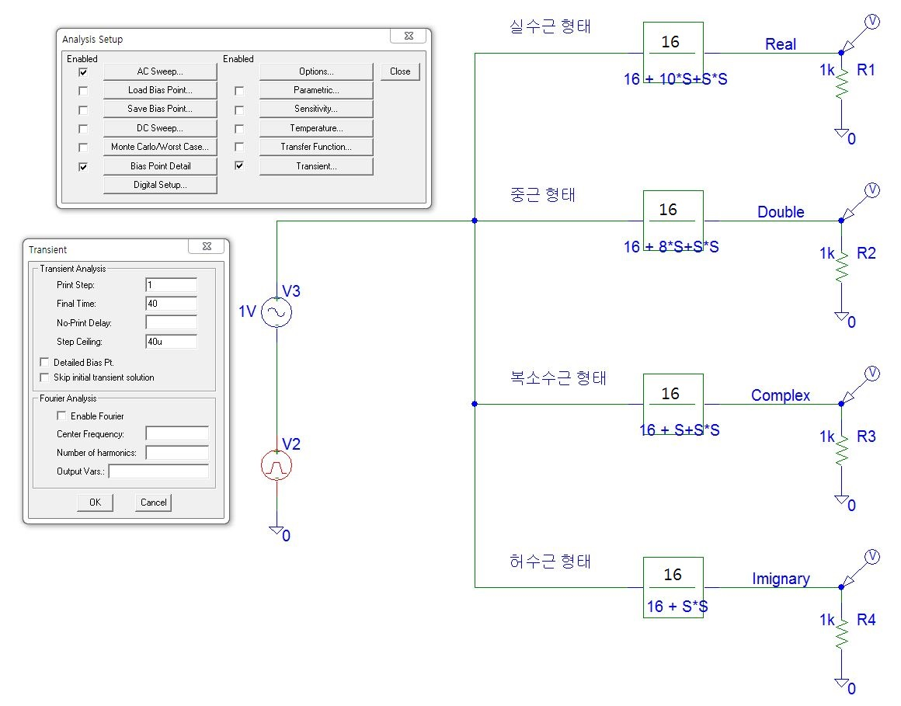

**Example 3. Transient Response with respect to variation of feedback gain**

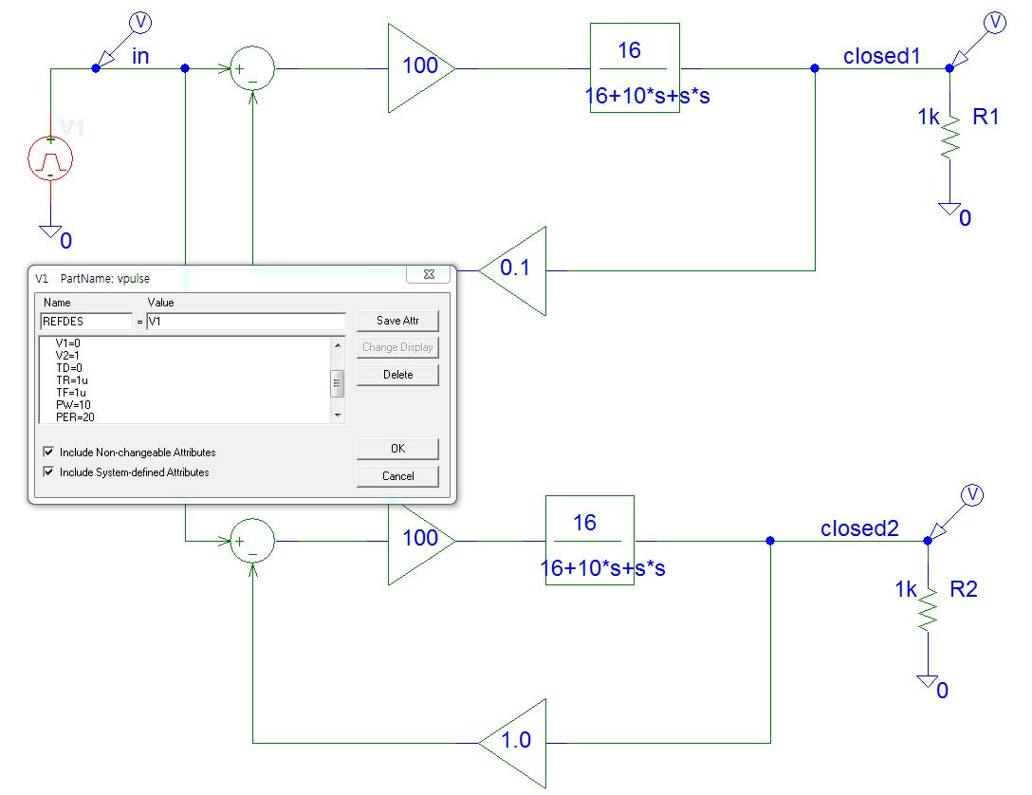

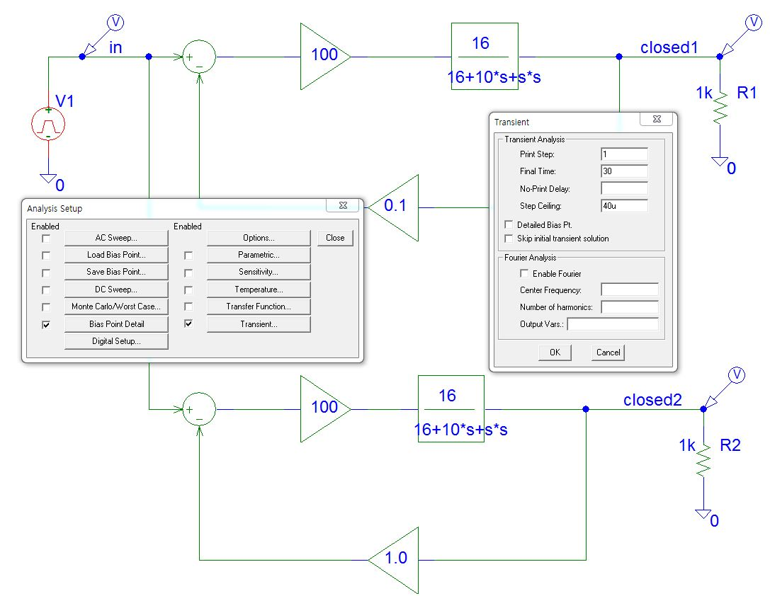

**Stability and Frequency Compensation**

**Oscillation in the Closed Loop**

Oscillatorsare circuits that produce an output waveform *without an external signal source*. The key to oscillator operation is **positive feedback**. A positive feedback network produces a feedback voltage (VF) that is *in phase* with the input signal (Vin) as shown in Figure 1. The amplifier shown in the figure produces a 180° voltage phase shift, and the feedback network introduces another 180° voltage shift. This results in a combined 360° voltage phase shift, which is the same as a 0° shift. Therefore, VF is in phase with Vin. (Positive feedback can also be achieved by using an amplifier and a feedback network that *both* generate a 0° phase shift.)

Figure 1 also illustrates the basic principle of how the oscillator produces an output waveform without any input signal. In Figure 1(a), the switch is momentarily closed, applying an input signal to the circuit. This results in a signal at the output from the amplifier, a portion of which is fed back to the input by the feedback network. In Figure 1(b), the switch is now open, but the circuit continues to oscillate because the feedback network is supplying the input to the amplifier. The feedback network delivers an input to the amplifier, which in turn generates an input for the feedback network. This circuit action is referred to as **regenerative feedback** and is the basis for all oscillators.

An oscillator needs a brief *trigger signal* to start the oscillations. Most oscillators provide their own trigger simply by turning the circuit on. So far, we have established two requirements for oscillator operation:

1. The circuit must have *regenerative feedback*; that is, feedback that results in a combined 360°(or 0°) voltage phase shift around the circuit loop.
2. The circuit must receive some *trigger signal* to start the oscillations.

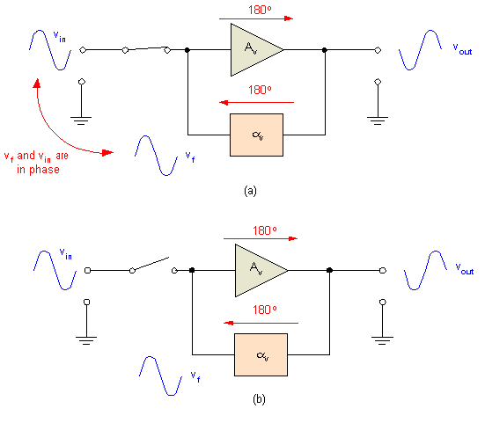

Figure 1 Regenerative feedback.

There is one other requirement for oscillator operation. The circuit must fulfill a condition referred to as the *Barkhausen criterion*. You were shown that the active component in a feedback amplifier produces a voltage gain () while the feedback network introduces a loss or attenuation (). In order for an oscillator to work properly, the following relationship must be met:

This relationship is called the **Barkhausen criterion**.

If this criterion is not met, one of the following occurs:

1. If , the oscillations die out after a few cycles.
2. If , the oscillator drives itself into saturation and cutoff clipping.

These principles are illustrated in Figure 2.

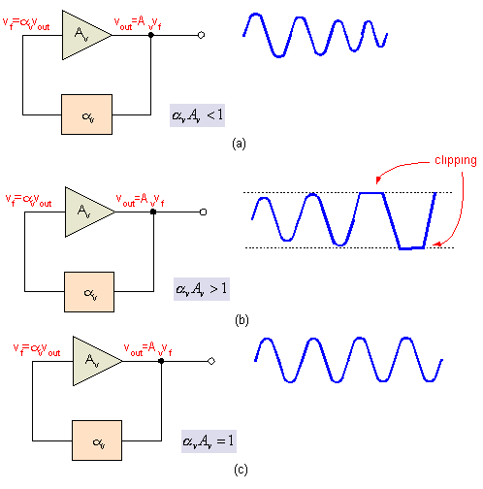

Figure 2 The effects of on oscillator operation.

If , each oscillation results in a lower-amplitude signal being fed back to the input (as shown in Figure 2a). After a few cycles, the signal fades out. This loss of signal amplitude is called *damping*. If , each oscillation results in a larger and larger signal being fed back to the input (as shown in Figure 2b). In this case, the amplifier is quickly driven into clipping. When , each oscillation results in a consistently equal signal being fed back to the input (as shown in Figure 2c). One final point: Since there is always some power loss in the resistive components, in practice must always be just slightly greater than 1.

**Gain and Phase margin**

The **gain margin** is found by using the phase plot to find the frequency **WGM**, where the phase angle is **180°**. This is shown in *figure G* below . By observing  the magnitude plot at this frequency, the Gain margin **GM** can be determined, which is the gain required to raise the magnitude curve to **0 dB**, shown in yellow colour.

The **phase margin** can be found by using the magnitude curve to find the frequency **WPM**, where the gain is **0 dB**. By then looking on the phase curve at that frequency, the Phase margin **PM**, is the difference between thephase value and 180°, shown in fuchsia colour. This way, every system characterised by bode plots as gain and phase plots, it's gain and phase margins can be found easily.

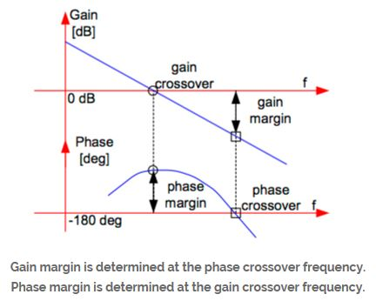

**Dominant Pole Compensation Technique**

In this method the manufacturer introduces an artificial break frequency (pole, fC) which causes the gain to drop to 0 dB before the first natural one (fC1) occurs.

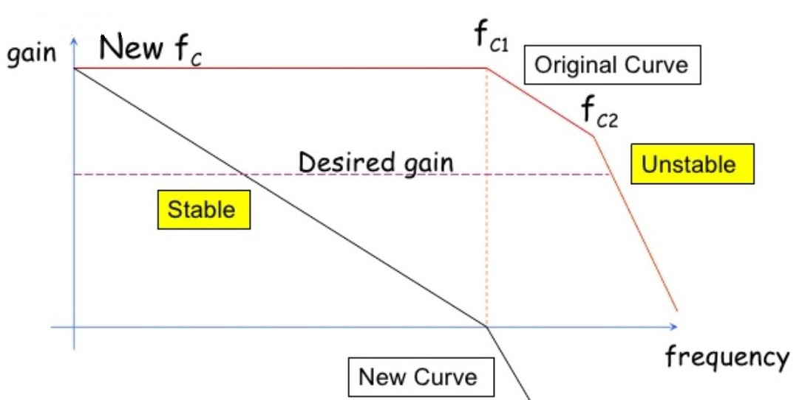



**Frequency Compensation Technique**

This method is similar to the dominant pole compensation technique. This time its position is selected by the user and is positioned so that the gain drops to the desired gain at the point the first natural break frequency occurs.

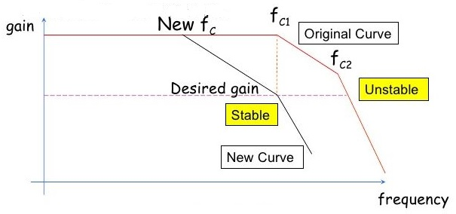

**Example. Dominant pole compensation technique**

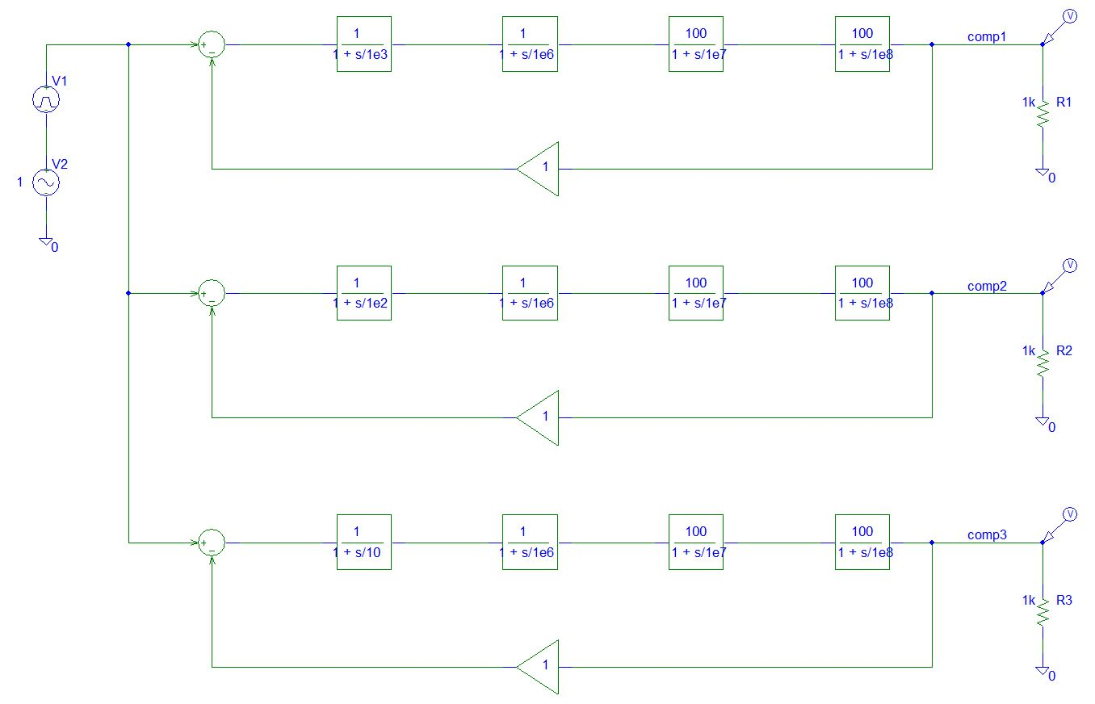

V1 Source : V1=0, V2=1, TR=1n, TF=1n, PW=1m, PER=2m

Transient analysis set up : Final time=100u, Step ceiling=10n

V2 source : VAC source, Amplitude=1V

AC sweep set up : Start frequency=10 Hz, End frequency=10 GHz